Quest Merchant Bank Limited Unveils New Brand Identity, Signalling Next Phase of Strategic Growth
Lagos, Nigeria – April, 2026 - Quest Merchant Bank Limited has unveiled its new brand identity, marking a significant step in the Bank’s ongoing evolution following its recent name change.
The refreshed identity reflects the Bank’s strategic direction as it deepens its role as a trusted partner to institutions and investors, providing insight-driven financial solutions and a disciplined approach to supporting long-term value creation.
With a strong legacy of execution and a deep understanding of key sectors, the Bank continues to differentiate itself through measured decision-making, strong risk management, and the ability to navigate increasingly complex market environments. The new identity brings these qualities into sharper focus, while signalling a renewed emphasis on growth, innovation, and relevance in a changing financial landscape.
Quest Merchant Bank remains focused on supporting clients across their growth journey, helping to unlock opportunities, structure transactions effectively, and provide the clarity required to make confident financial decisions in dynamic conditions.
Commenting on the development, the Ag. Managing Director/CEO, Afolabi Olorode, stated:
“Our new brand identity represents an important step in our journey as Quest Merchant Bank. It reflects both who we are and where we are headed, an institution grounded in experience yet firmly focused on the future. As we continue to evolve, our priority remains to provide our clients with the clarity, confidence, and strategic support they need to achieve their long-term objectives.”
The refreshed identity will be progressively reflected across the Bank’s touchpoints, aligning its visual presence with its strategic ambition and ongoing investments in innovation, digital transformation, and service delivery.
Quest Merchant Bank remains focused on reinforcing its position as a leading merchant bank, trusted by institutions and investors to unlock value and deliver sustainable financial outcomes.

For further enquiries, please contact:
Email: info@questmb.com

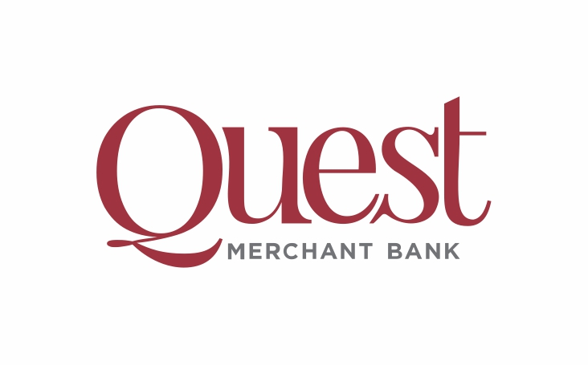

About Quest Merchant Bank Limited
Quest Merchant Bank Limited is a Nigerian licensed merchant bank providing Corporate and Investment Banking, Global Markets, and Wealth Management services to corporate, institutional, and public sector clients. The Bank is committed to strong governance, disciplined execution, and sustainable value creation.

